Botswana

## Respect for rule of law (ROL) data

The data set shows the data on the respect of the rule of law for the country.

## # A tibble: 19 x 5  
## country iso3c date ruleOfLaw ruleOfLawCategory4   
## <chr> <chr> <dbl> <dbl> <chr>   
## 1 Botswana BWA 1996 0.585 ROL moderately respected  
## 2 Botswana BWA 1998 0.678 ROL moderately respected  
## 3 Botswana BWA 2000 0.595 ROL moderately respected  
## 4 Botswana BWA 2002 0.570 ROL moderately respected  
## 5 Botswana BWA 2003 0.731 ROL moderately respected  
## 6 Botswana BWA 2004 0.653 ROL moderately respected  
## 7 Botswana BWA 2005 0.640 ROL moderately respected  
## 8 Botswana BWA 2006 0.623 ROL moderately respected  
## 9 Botswana BWA 2007 0.650 ROL moderately respected  
## 10 Botswana BWA 2008 0.696 ROL moderately respected  
## 11 Botswana BWA 2009 0.666 ROL moderately respected  
## 12 Botswana BWA 2010 0.675 ROL moderately respected  
## 13 Botswana BWA 2011 0.668 ROL moderately respected  
## 14 Botswana BWA 2012 0.662 ROL moderately respected  
## 15 Botswana BWA 2013 0.596 ROL moderately respected  
## 16 Botswana BWA 2014 0.634 ROL moderately respected  
## 17 Botswana BWA 2015 0.595 ROL moderately respected  
## 18 Botswana BWA 2016 0.532 ROL moderately respected  
## 19 Botswana BWA 2017 0.514 ROL moderately respected

## Respect for rule of law (ROL) trend

The plot shows the trend of the respect for the rule of law for the country.

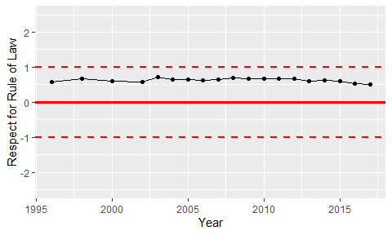

Trend of the Respect for the Rule of Law